IP POE Powered Ceiling Speaker
FIP-906POE
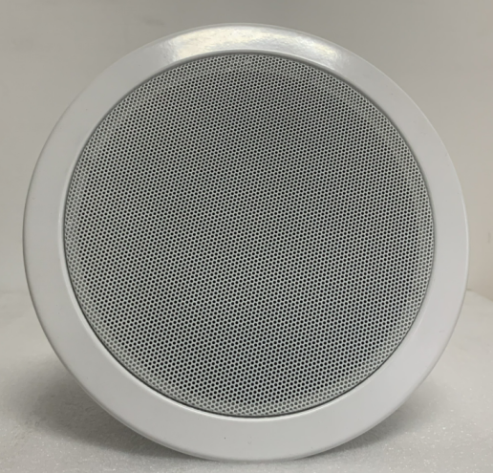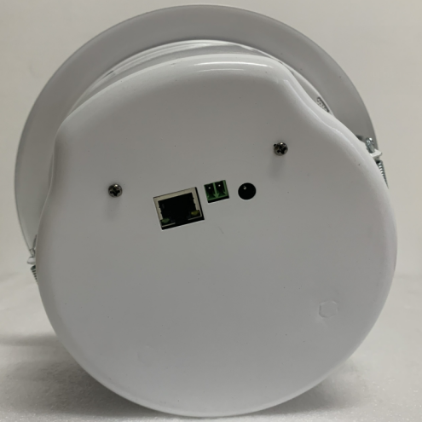
Description:

The IP POE Powered Ceiling Speaker is the latest in IP technology. This Power over Ethernet (Compatible with both IEEE 802.3af & IEEE 802.3at) VoIP mass notification device has network-controlled speaker volume, scheduled program broadcast, priority-based multicast streaming, group definition, working status supervision, remote online technical support and trouble shoot. The speaker is capable of broadcasting audio through multicast.

The POE powered ceiling speaker enable to be built up an IP based sound system through a single CAT5 or CAT6 wire. The single CAT5 cable is used for control data, signal data and power supply, by this way, the layout cost will be much decreased without any consideration of AC nor DC power supply.

The POE powered ceiling speaker is compatible with universal POE switch, thus the POE speaker works with existing POE LAN/WAN & internet network and fiber-optical cable, no need dedicated network to be built-up. So it is very useful for office, hotel, school, bank, factory & shopping mall where POE network is already there.

The POE ceiling speaker is designed with 6” full range ceiling speaker with 15W class-D amplifier module build in, metal back cover.

Features:
- Support with existing POE switch network system
- Compatible with both IEEE 802.3af & IEEE 802.3at
- IP based POE powered 6W ceiling speaker
- Single network cable for control, signal and power supply
- Same POE speakers enable to be several group or zone defined
- Different music or voice message simultaneously broadcasted through different POE speakers.
- Paging prioritization and background music system
- Network adjustable speaker volume
- Support DHCP, no need to set IP address.
- Software support online supervision, easy to know the status of speaker
- With contact in and contact out trigger to work with other third system, like fire button

IP POE Powered Ceiling Speaker
FIP-906POE

Specifications:
Model | FIP-906POE
Description | IP Based POE Ceiling Speaker
Power Output | 6Watts RMS (1KHz@-3dB)
Built-in Amplifier | 6W Class D amplifier
Network I/F | 10/100Mbps
Protocol | ARP, TCP/IP, UDP, ICMP & IGMP (Group Broadcast)
Audio Format | MP3/MP2
Audio Quality | 16digit stereo CD level
Sampling Rate | 8K~48K
Bit Rate | 8K~512Kbps
Sensitivity | 92dB/1W/1M
S/N Ratio | ≧85dB
THD | ≦0.1%
Frequency Response | 100-18KHz（±3dB）
Connector | One RJ45 port for existing LAN/WAN & internet， 1DC input and 1 contact in and contact out.
Power Input | POE 802.3af or POE 802.3at & DC 12V
Operation Temp | -30 to 55℃
Dimension | Φ199 x D95mm
Cutout Size | 166mm
Weight | 0.9kg

System Diagram:
